**2024**

1. State *two* factors affecting the speed of rotation of the coil in a D.C. motor.
2. Below is the diagram of a transformer:



1. Identify the type of transformer.
2. In this type of transformer which of the wire is thicker, the primary or the secondary? Give a reason
3. State one factor that affects the magnitude of induced current in an AC generator
4. Given below is a circuit to study the magnetic effect of electric current. ABCD is a cardboard kept perpendicular to the conductor XY. A magnetic compass is placed at the point P of the cardboard. P1 and P2 are the positions of the magnetic compass, before and after passing a current through XY respectively.

1. Name the rule that is used to predict the direction of deflection of the magnetic compass.
2. State the direction of current in the conductor (X to Y or Y to X) when the circuit is complete.
3. If resistance R is increased, then what will be the effect on the magnetic lines of force around the conductor?

**2023**

1. If the strength of the current flowing through a wire is increased, the strength of the magnetic field produced by it:
2. decreases
3. increases
4. remains the same
5. first increases then decreases
6. A copper conductor is placed over two stretched copper wires whose ends are connected to a D.C. supply as shown in the diagram.

* 1. What should be the magnetic poles at the points A and B lying on either side of the conductor to experience the force in the upward direction?
  2. Name the law used to find these polarities.

1. The diagram below shows a cardboard on which iron filings are kept. A wire bent in the form of a loop is seen passing through the cardboard. When current flows through it the iron filings arrange themselves as shown below.

1. State the polarities of the *battery* at A and B.
2. State the effect on the magnetic field if an iron rod is held along the axis of the coil.
3. State one way to:
   1. Change the polarity of the *coil*.
   2. *Decrease* the strength of the magnetic field around the coil.

**2022**

1. A conductor AB is kept along north south direction of the earth above a magnetic needle as shown below. When the key K is closed then

* 1. the needle will not show any deflection.
  2. the needle will deflect towards east.
  3. the needle will turn in the opposite direction i.e., towards south.
  4. the needle will deflect towards west.

1. A coil wound around a piece of soft iron can become an electromagnetic only when
2. the circuit is open.
3. a magnetic compass is present in the vicinity.
4. a galvanometer is connected to the circuit.
5. a current flows in the circuit.
6. The diagram below shows a magnetic compass kept closer to a coil AB wound around a hollow cylindrical cardboard: [3]

1. After studying the circuit and the magnetic compass carefully, state whether the switch S1 is open or closed.
2. How did you arrive at the conclusion in (a)?
3. What is the purpose of placing the magnetic compass in the above setup?
4. Name two factors on which the force experienced by a conductor carrying current, placed in a magnetic field, depends. Also, state how these factors affect the force. [3]
5. With the help of which rule you can determine the direction of force acting on a current carrying conductor placed in a magnetic field?

**2020**

1. When a current carrying conductor is placed in a magnetic field, it experiences a mechanical force. What should be the angle between the magnetic field and the length of the conductor so that the force experienced is:
   1. Zero
   2. Maximum?
2. The diagram below shows a loop of wire carrying current I:

1. What is the magnetic polarity of the loop that faces us?
2. With respect to the diagram how can we increase the strength of the magnetic field produced by this loop?
3. The diagram below shows the core of a transformer and its input and output connections

1. State the material used for the core.
2. Copy and complete the diagram of the transformer by drawing input and output coils.
3. Answer the following questions
   1. Draw a neat labeled diagram of a d.c. motor.
   2. Write any one use of a d.c. motor.

**2019**

1. A magnet kept at the centre of two coils A and B is moved to and fro as shown in the diagram. The two galvanometers show deflection.

State with a reason whether:

x > y

or

*x < y.* [*x* and *y* are magnitudes of deflection.]

1. Draw a neat labeled diagram of an A.C. generator.
2. The diagram below shows a magnetic needle kept just below the conductor AB which is kept in North South direction.

1. In which direction will the needle deflect when the key is closed?
2. Why is the deflection produced?
3. What will be the change in the deflection if the magnetic needle is taken just above the conductor AB?
4. Name one device which works on this principle

**2018**

1. How is the e.m.f. across primary and secondary coils of a transformer related with the number of turns of coil in them?
2. On which type of current do transformers work?
3. State any two advantages of electromagnets over permanent magnets.
4. The diagram shows a coil wound around a U shape soft iron bar AB.

1. What is the polarity induced at the ends A and B when the switch is pressed?
2. Suggest one way to strengthen the magnetic field in the electromagnet.
3. What will be the polarities at A & B if the direction of current is reversed in the circuit?

**2017**

1. State two causes of energy loss in a transformer [2]
2. Draw a labelled diagram of an AC generator. Write the function of its two main parts [4]

**2016**

1. Which coil of a step-up transformer is made thicker and why? [2]

**2014**

1. Name a common device that uses electromagnet [1]
2. (i) Name two factors on which the magnitude of an induced EMF in the secondary coil depends

(ii) In the following diagram an arrow shows the motion of the coil towards the bar magnet

1. State in which direction the current flows, A to B or B to A?
2. Name the law used to come in the conclusion

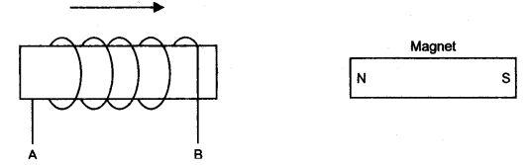

**2013**

1. (i) Draw a simple labelled diagram of a DC electric motor

(ii) What is the function of the split rings in a DC motor

(iii) State one advantage of AC over DC [4]

1. You have been provided with a solenoid AB

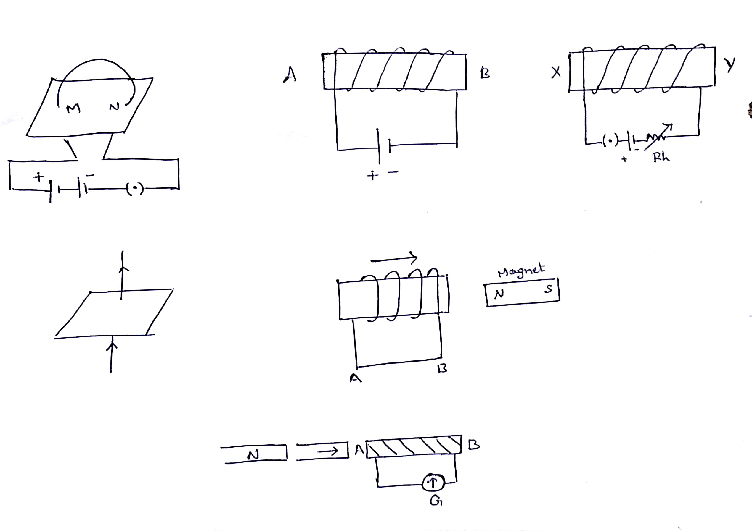

* 1. What is the polarity at end A
  2. Give one advantage of an electromagnet over a permanent magnet [2]

**2012**

1. The diagram given shows a current carrying loop or a circular coil passing through a sheet of cardboard at the points M and N. the sheet of cardboard is sprinkled uniformly with iron fillings
   1. Copy the diagram and draw an arrow on the circular coil to show the direction of current flowing through it
   2. Draw the pattern of arrangement of iron fillings when current is passed through the loop [3]

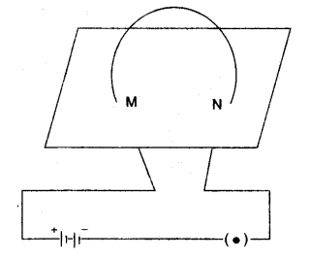

1. (i) What is an AC generator or dynamo used for

(ii) Name the principle on which it works [2]

**2011**

1. Draw a representative diagram of a DC motor. Label the following in your diagram
   1. The field magnet
   2. The armature
   3. Commutator
   4. Wire brushes

What is the energy change in this case [5]

**2010**

1. (i) State two ways by which the magnetic field of a solenoid can be made stronger

(ii) What material is used for making the armature of an electric bell? Give reason for using this material [4]

1. (i) A straight wire conductor passes vertically through a piece of cardboard sprinkled with iron fillings as shown in the figure below. Copy the diagram and show the setting of iron fillings when a current is passed through the wire in the upward direction and the cardboard is tapped gently. Draw arrows to represent the direction of the magnetic field lines

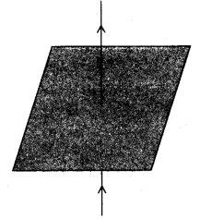

(ii) Name the law which helped you to find the direction of the magnetic field line [3]

1. Give two differences between a DC motor and an AC generator [2]
2. A device is used to transform 12 V AC to 200 V AC
   1. What is the name of this device
   2. Name the principle of which it works [2]

**2009**

1. The figure given alongside shows an electromagnet.
   1. What will be the polarity at the end X?
   2. Suggest a way by which the strength of the electromagnet referred to in the question may be increased [2]
2. (i) Draw a neat and labelled diagram to show the structure of an AC generator

(ii) State the energy conversion taking place in the AC generator when it is working [3]

**2008**

1. (i) Why does a magnetic needle show a deflection when brought close to a current carrying conductor

(ii) A wire bent into circle carries current in an anticlockwise direction. What polarity does this face of the coil exhibit [3]

1. (i) What is the name given to a cylindrical coil, whose diameter is less in comparison to its length

(ii) A piece of soft iron is placed inside the current carrying coil, what is the name given to the device

(iii) Give one use of the device named by you in part (ii) above [3]

1. State one point of similarity and one point of difference between an AC generator and DC motor [2]
2. Draw a simple sketch of stepdown transformer. Label the different parts in diagram. [2]

**2007**

1. (i) State two factors on which the strength of an induced current depends

(ii) When a solenoid that is carrying current is freely suspended it uses to rest along a particular direction. Why does this happen [3]

**2006**

1. What energy conversion take place during the working of a DC motor [1]
2. State two advantages of an electromagnet over a permanent magnet [2]
3. What will happen to a compass needle when the compass is placed below a wire and a current is made to flow through the wire? Give a reason to justify your answer [2]

**2005**

1. State the function of a split ring in a DC motor [2]
2. Draw a labelled diagram of an AC generator [2]
3. State the energy change which takes place when a magnet is moved inside a coil having a galvanometer at its end. Name this phenomenon. [2]
4. Mention any two reasons, why a soft iron core is used within the coil of a moving coil galvanometer [2]

**2004**

1. Explain briefly, how a magnet can be demagnetised using an AC current [3]
2. State two ways by which the EMF in an AC generator can be increased [2]
3. (i) Draw a labelled diagram to show the various components of a step down transformer

(ii) State the main difference between a step-up and step-down transformer

**2003**

1. The diagram shows a coil connected to a galvanometer ‘G’. the galvanometer shows a deflection to the right when the N-pole of a powerful magnet is moved to the right as shown

https://www.syvum.com/cgi/online/serve.cgi/exam/icse/phy_q6b_2003.jpg

* 1. Explain, why the deflection occur in the galvanometer
  2. Does the direction of the current in the coil appear clockwise or anticlockwise, when viewed from the end ‘A’
  3. State the observation in ‘G’ when the coil is moved away from ‘N’
  4. State the observation in ‘G’ when both the coil and the magnet are moved to the right at the same speed [5]

**2002**

1. State two advantages of an electromagnet over a permanent magnet [2]
2. Draw a sketch of an electric bell with electrical connections and label the main parts. Why is the armature made of soft iron and not of steel [4]
3. State two dissimilarities between a DC motor and an AC generator [2]

**2001**

1. (a) Draw a representative diagram of a dc motor. Label the following in your diagram [4]
   1. The field magnet
   2. The armature
   3. Commutators
   4. Wire brushes

(b) What is the energy change in this case? [1]

**2000**

1. State two characteristics of a primary coil of a step-up transformer when compared to the secondary coil [2]
2. With respect to a D.C. motor, state
   1. The energy change that takes place
   2. The principle on which it operates [2]

**1999**

1. What is an electromagnet? State two ways by which the strength of electromagnet can be increased. [3]
2. (i) Draw a labelled diagram of the device you would use to transform 200 volts a.c. to 15 volts a.c.? [2]

(ii) What is the name of this device? [1]

**1998**

1. The alongside diagram shows two straight wires carrying current. Copy the diagram and draw the pattern of lines of force around them and mark their directions.   
   http://www.icseguess.com/papers/question_bank/x/images/1998_physics4.jpg
2. State two ways of increasing the speed of rotation of a D.C. motor. [2]

**1997**

1. Diagram alongside shows a circuit containing a coil wound on the long and thin hollow cardboard tube. Copy the diagram. [4]

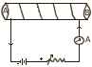

1. Show the polarity acquired by each face of the solenoid.
2. Draw the magnetic lines of force inside the coil and also show their directions.
3. Mention two methods to increase the strength of the magnetic field inside the coil.
4. (i) Draw a neat labelled diagram of an a.c. generator.

(ii) What is the magnitude of the emf induced in the coil when its plane becomes parallel to the magnetic held? [4]

**1996**

1. (i) Name the principle on which functioning of a transformer depends. [4]

(ii) What is the function of a step-up transformer?

(iii) Can a transformer work when it is connected to a d.c. source?

(iv) Diagram given alongside shows schematically part of a step-down transformer. Draw the complete diagram in your answer sheet.

http://www.icseguess.com/papers/question_bank/x/images/1996_physics7.jpg